Full Stack Development with MERN
Project Documentation
1. Introduction
• Project Title: ShopEZ – MERN Stack E-Commerce Web Application By - Adula Sreenidhi
Role - Full Stack Developer
2. Project Overview
• Purpose:
ShopEZ is a full-stack e-commerce web application
developed using the MERN Stack (MongoDB,
Express.js, React.js, and Node.js). The application
allows users to browse products, add products to cart,
manage wishlists, place orders, and view order history. An admin can manage products and monitor orders
through a dedicated admin dashboard.
Features:
User Features
● User Registration
● User Login
● Product Search
● Category Filtering
● Product Details Page
● Add to Cart
● Remove from Cart
● Wishlist Management
● Move Wishlist Items to Cart
● Place Orders
● Order History
● Update Delivery Address
Admin Features
● Admin Dashboard
● View Total Users
● View Total Products
● View Total Orders
● Add Products
● Update Product Status
● View All Orders
3. Architecture
• Frontend: developed using React.js.
Main Components:
● Home.jsx
● Login.jsx
● Register.jsx
● Navbar.jsx
● Cart.jsx
● Wishlist.jsx
● Orders.jsx
● Profile.jsx
● ProductDetails.jsx
● AdminDashboard.jsx
● AddProduct.jsx
● AllProducts.jsx
● AllOrders.jsx
React Router is used for navigation between pages. Axios is used for API communication.
React Toastify is used for notifications.
• Backend: developed using Node.js and Express.js. Routes
● authRoutes
● productRoutes
● cartRoutes
● orderRoutes
● wishlistRoutes
● dashboardRoutes
Controllers
● authController
● productController
● cartController
● orderController
● wishlistController
● dashboardController
Middleware
● protect
● adminOnly
• Database: MongoDB is used as the database.
User Collection -
_id
name
email
password
role
Product Collection -
_id
name
description
price
category
Cart Collection -
_id
userId
productId
quantity
Order Collection -
_id
userId
productId
quantity
address
status
4. Setup Instructions • Prerequisites:
● Node.js
● MongoDB
● MongoDB Compass ● VS Code
● Git
Installation:
Server Setup :
cd backend
npm install
npm start
Client Setup :
cd frontend
npm install
npm run dev
5. Folder Structure
• Client:
frontend
│
├── public
│
├── src
│ │
│ ├── assets
│ │ ├── samsung.jpg
│ │ ├── iphone.jpg
│ │ ├── banner.webp
│ │ └── other product images │ │
│ ├── components
│ │ ├── Navbar.jsx
│ │ ├── ProtectedRoute.jsx │ │ └── AdminRoute.jsx │ │
│ ├── pages
│ │ ├── Home.jsx
│ │ ├── Login.jsx
│ │ ├── Register.jsx
│ │ ├── ProductDetails.jsx │ │ ├── Cart.jsx
│ │ ├── Wishlist.jsx
│ │ ├── Orders.jsx
│ │ ├── Profile.jsx
│ │ ├── AdminDashboard.jsx │ │ ├── AddProduct.jsx │ │ ├── AllProducts.jsx │ │ └── AllOrders.jsx
│ │
│ ├── App.jsx
│ └── main.jsx
│
├── package.json
└── vite.config.js
• Server:
backend
│
├── config
│ └── db.js
│
├── controllers
│ ├── authController.js │ ├── productController.js │ ├── cartController.js │ ├── orderController.js │ ├── wishlistController.js │ └── dashboardController.js │
├── middleware
│ ├── authMiddleware.js │ └── adminMiddleware.js │
├── models
│ ├── User.js
│ ├── Product.js
│ ├── Cart.js
│ ├── Order.js
│ └── Wishlist.js
│
├── routes
│ ├── authRoutes.js
│ ├── productRoutes.js │ ├── cartRoutes.js
│ ├── orderRoutes.js
│ ├── wishlistRoutes.js │ └── dashboardRoutes.js │
├── server.js
└── package.json
6. Running the Application
Frontend:
cd client
npm run dev
Runs on: http://localhost:5173
Backend:
cd server
npm start
Runs on: http://localhost:5000
7. API Documentation
Authentication APIs
Register User : POST /api/auth/register Login User : POST /api/auth/login
Product APIs
Get All Products : GET /api/products Add Product : POST /api/products
Cart APIs
Add To Cart : POST /api/cart/add
Get Cart Items : GET /api/cart/:userId Remove Cart Item : DELETE /api/cart/:id
Wishlist APIs
Add To Wishlist : POST /api/wishlist/add Get Wishlist : GET /api/wishlist/:userId Remove Wishlist Item : DELETE /api/wishlist/:id
Order APIs
Place Order : POST /api/orders/add
Get Orders : GET /api/orders/:userId
Get All Orders : GET /api/orders
Dashboard API
Dashboard Statistics : GET /api/dashboard
8. Authentication
Authentication is implemented using JSON Web Tokens(JWT).
Process:
1. User registers an account.
2. User logs into the system.
3. Backend generates a JWT token.
4. Token is stored in localStorage.
5. Protected routes verify the token before granting access. 6. Admin routes additionally verify the user role.
Middleware Used : protect , adminOnly
9. User Interface
The ShopEZ application provides a simple and user-friendly interface for both customers and administrators. The user interface is developed using React.js and is designed to provide smooth navigation and an efficient shopping experience.
Registration Page -
The Registration Page allows new users to create an account by providing their name, email address, and password. User details are validated before being stored in the database.
Login Page -
The Login Page enables registered users to securely access the application using their email and password. Upon successful authentication, users are redirected to the home page.
Home Page -
The Home Page displays all available products. Users can browse products, search for specific items, and filter products based on categories. Each product card displays the product image, name, description, and price.
Product Details Page -
The Product Details Page provides complete information about a selected product, including its image, description, category, and price. Users can view detailed information before making a purchase decision.
Shopping Cart Page -
The Cart Page displays all products added to the cart. Users can increase or decrease product quantities, remove items from the cart, view the total price, and place orders. A discount is automatically applied during total price calculation.
Orders Page -
The Orders Page displays all orders placed by the user. Users can view product details, delivery address, order quantity, and current order status.
Add Product Page -
The Add Product Page allows administrators to add new products by entering details such as product name, description, category, and price.
All Products Page -
The All Products Page enables administrators to view all available products and perform management operations such as updating or deleting products.
All Orders Page -
The All Orders Page allows administrators to monitor customer orders and update order statuses whenever necessary.
10. Testing
Testing was performed using Thunder Client :
Used for testing:
● Authentication APIs
● Product APIs
● Cart APIs
● Wishlist APIs
● Order APIs
● Dashboard APIs
Manual Testing
Verified:
● User Registration
● User Login
● Product Search
● Add To Cart
● Wishlist Functionality
● Order Placement
● Admin Operations
All major functionalities of the ShopEZ application were tested successfully. The application correctly handles user authentication, product management, cart operations, wishlist operations, order processing, and administrative functions. Data is stored and retrieved successfully from MongoDB, and communication between the frontend and backend operates as expected.
11. Screenshots or Demo
Register page :
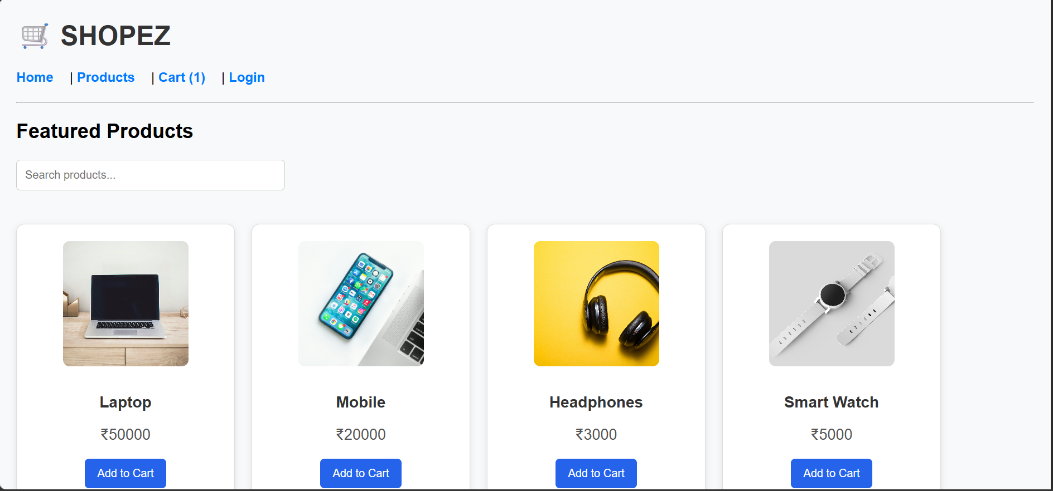

12. Known Issues
● Product images are currently stored locally in the frontend assets folder.
● Revenue calculation is not implemented in the dashboard. ● Online payment integration is not available.
● Limited User Profile Features
● No Product Reviews and Ratings
13. Future Enhancement

● Payment Gateway Integration ● Product Reviews and Ratings ● Email Notifications
● Product Image Upload Feature ● Sales Analytics Dashboard
● Improved User Profile Management ● Deployment to Cloud Platform ● Mobile Application Support

